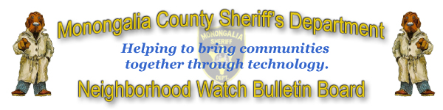
The Monongalia County Neighborhood Watch Bulletin Board was conceived to bring you, the concerned and law abiding citizen, a way of working with your neighbors and local law enforcement. We, at the Monongalia County Sheriff’s Department, wanted a way in which to further involve citizens like yourself and make law enforcement more accessible to your communities. So through this bulletin board we hope to bring you more in touch with your neighbors and with us, your local law enforcement professionals. The instructions that follow are to help you sign on to your neighborhood bulletin board. If you have any questions about the board itself please feel free to email bbhelp@ulesystems.com.

- Open your internet browser and go to http://ules.monsheriff.com/neighborhoodwatch
- Once there scroll to the bottom and select your neighborhood from the list provided.
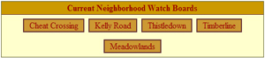

Example of neighborhood list

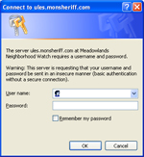
- Once you select your neighborhood from the list, a box will appear asking for a username and password. This information will be provided to you by either a law enforcement officer or someone within your neighborhood who has volunteered to coordinate this part of your neighborhood watch program. This level of protection has been added to help secure your neighborhood bulletin board from those outside of your neighborhood.

An example of the login box

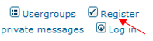
- After you have logged in to the bulletin board area you will see several forums that you can look at. However you will not be able to post topics for discussion nor respond to topics without creating a user account for the bulletin board itself. Also there are several forums which you will not see until an account has been created. Look toward the top of the page for the Register link which looks like the example below.

An example of the Register link

- After clicking on the Register link you will be brought to the Terms and Conditions for the bulletin board. After reading these carefully, click agree to continue.
Note: The reason it asks if you are over 13 years of age is due to the Children’s Online Privacy Protection Act. If you would like to read more about this Act please follow the link http://www.coppa.org/

- Next is the Registration Information page. Here you will create your account, enter your password and email address for accessing the bulletin board. Please note that a valid email address is required. This is because your account will not be activated until after you receive an activation email from the bulletin board. Your email address will remain private and will not be given out to anyone. We take great care in keeping your personal information as safe as we can. We will not spam your account in anyway. It is only used to send you needed information.

- Once all your information is complete click the Submit button at the bottom of the page. Once this is done you will be prompted to go to your email and click on the link to activate your account.

- Once your account is activated then you can come back to the front page of the bulletin board and click the Log in link at the top of the page and start interacting with your community.
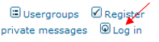

An example of the Register link

- We at the Monongalia County Sheriff’s Department hope you find this Neighborhood Watch Bulletin Board as useful as we do. Remember that law enforcement personnel will be interacting with your community on this board to help facilitate a better relationship and understanding for everyone.

For those of you who are wondering how you will know for sure that you are talking to an actual law enforcement officer, we’d like to offer this information. All law enforcement officers will be a part of a special group within the bulletin board which will say next to their name Monongalia County Sheriff’s Deputy. This group can only be give by the administrator of this bulletin board which is a law enforcement officer himself.

Once again, if you are having any issues with the board and wish to email a technical representative please email bbhelp@ulesystems.com

Please remember the following, no law enforcement officer, administrator, or technical support personnel will ever ask you for your password. If anyone from these groups does ask you please notify bbhelp@ulesystems.com immediately.

Thank you and welcome to the Monongalia County Sheriff’s Department Neighborhood Watch Bulletin Board.

Joseph C. Bartolo
Monongalia County Sheriff

Allen Kisner
Monongalia County Chief Deputy

